**AI ASSIGNMENT-4.3**

NAME: Pranavi Pamera

HALL NO:2403A51328

BATCH:13

**TASK-1:**

* **Zero-shot:** Prompt AI to write a function that checks whether a given year is a leap year.

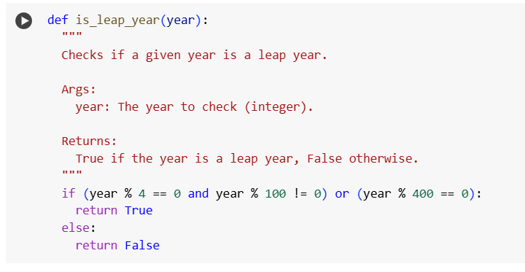

* **One-shot**: Give one input-output example to guide AI in writing a function that converts centimeters to inches.

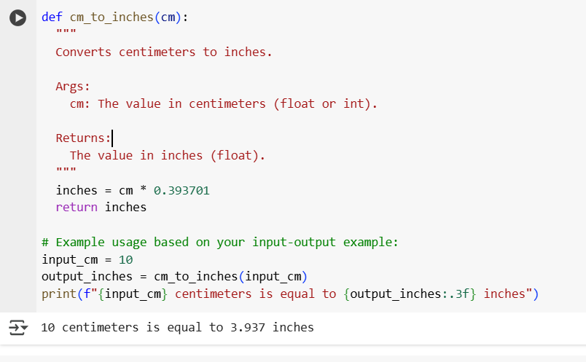

**TASK-3:**

* **Few-shot:** Provide 2–3 examples to generate a function that formats full names as “Last, First”.

**TASK-4:**

* Compare zero-shot and few-shot prompts for writing a function that counts the number of vowels in a string**.**

| **Feature** | **Zero-Shot Prompting** | **Few-Shot Prompting** |
| --- | --- | --- |
| **Description** | Instruction only, no examples. | Instruction with 2-3 input-output examples. |
| **Effort** | Less effort (only need instruction). | More effort (need to prepare examples). |
| **Accuracy** | Can be less accurate for complex tasks. | Generally more accurate, especially for complex or nuanced tasks. |
| **Use Case** | Simple, well-understood tasks. | Complex tasks, specific formats/styles. |
| **Cost** | Potentially lower cost per query. | Potentially higher cost per query (due to longer prompts). |
| **Control** | Less direct control over output format. | More direct control over output format and style. |

**TASK-5:**

* Use few-shot prompting to generate a function that reads a .txt file and returns the number of lines.

